**AdventureWorksDW2014 - Query**

**Database**: AdventureWorksDW2014 – Dimensional Model

**Query 1**

* What are the total sales, total cost & number of orders by product category?

Select pca.EnglishProductCategoryName as Category,

sum(FR.UnitPrice*FR.OrderQuantity) as Total_Sales,

sum(FR.ProductStandardCost*FR.OrderQuantity) as Total_cost

From FactResellerSales as FR

join DimProduct as pro

on FR.ProductKey = pro.ProductKey

join DimProductSubcategory as sb

On pro.ProductSubcategoryKey=sb.ProductSubcategoryKey

Join DimProductCategory as pca

on pca.ProductCategoryKey=sb.ProductCategoryKey

group by pca.EnglishProductCategoryName

TOTAL ROWS:-4 rows

TABLE USED:- FactResellerSales, DimProduct, DimProductSubcategory,DimProductCategory

|  |  |
| --- | --- |
| INPUT COLUMNS | OUTPUT COLUMNS |
| pca.EnglishProductCategoryName | pca.EnglishProductCategoryName |
| FR.UnitPrice | sum(FR.UnitPrice*FR.OrderQuantity) as Total_Sales |
| FR.OrderQuantity | sum(FR.ProductStandardCost*FR.OrderQuantity) as Total_cost |
| FR.ProductStandardCost |  |

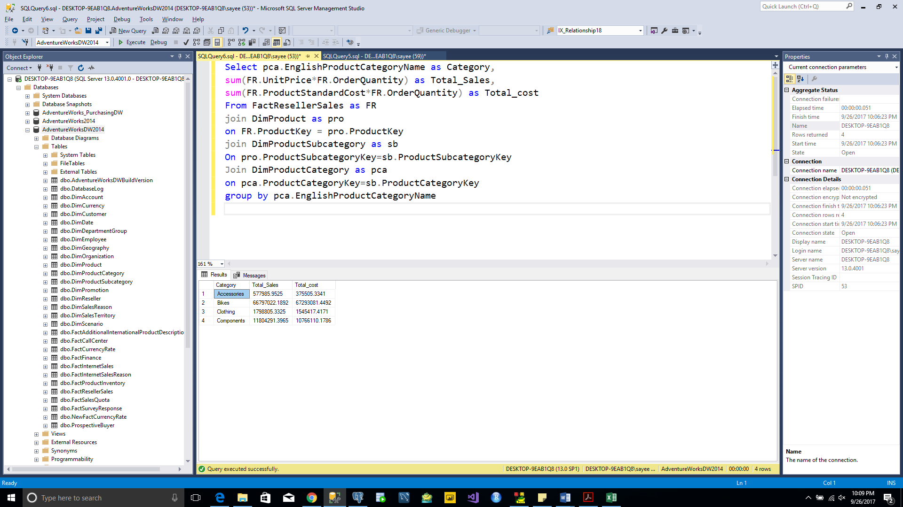

**Query 2**

* What are the total sales, total cost & number of orders by sales territory?

Select ST.SalesTerritoryRegion as SalesTerritory,

sum(FR.UnitPrice*FR.OrderQuantity) as Total_Sales,

sum(FR.ProductStandardCost*FR.OrderQuantity) as Total_cost

From FactResellerSales as FR

join DimSalesTerritory as ST

on FR.SalesTerritoryKey = ST.SalesTerritoryKey

group by ST.SalesTerritoryRegion

TOTAL ROWS:-10 rows

TABLE USED:- FactResellerSales, DimSalesTerritory

|  |  |
| --- | --- |
| INPUT COLUMNS | OUTPUT COLUMNS |
| ST.SalesTerritoryRegion | pro.EnglishProductName |
| FR.UnitPrice | sum(FR.UnitPrice*FR.OrderQuantity) as Total_Sales |
| FR.OrderQuantity | sum(FR.ProductStandardCost*FR.OrderQuantity) as Total_cost |
| FR.ProductStandardCost |  |

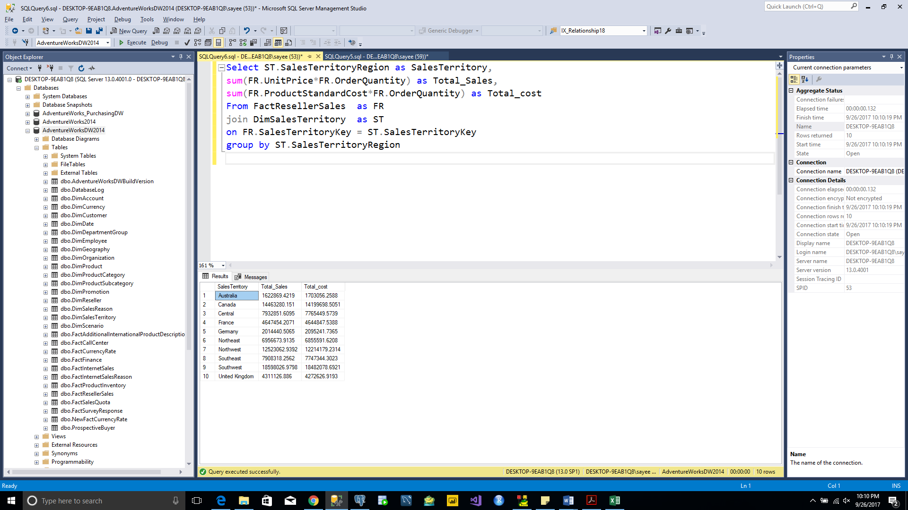

**Query 3**

* What are the total sales by month/year?

SELECT Concat(DATEPART(MONTH,FI.orderdate),',',DATEPART(YEAR ,FI.OrderDate)) AS Sales_year,

sum(FI.SalesAmount+RS.SalesAmount) AS Total_Sales

FROM FactInternetSales as FI

JOIN FactResellerSales as RS

ON FI.OrderDate = RS.OrderDate

GROUP BY DATEPART(YEAR ,FI.OrderDate),DATEPART(MONTH,FI.orderdate) ORDER BY DATEPART(YEAR ,FI.OrderDate) Desc

TOTAL ROWS:-33 rows

TABLE USED:- FactInternetSales, FactResellerSales

|  |  |
| --- | --- |
| INPUT COLUMNS | OUTPUT COLUMNS |
| FI.orderdate | Concat(DATEPART(MONTH,FI.orderdate),',',DATEPART(YEAR ,FI.OrderDate)) |
| FI.SalesAmount | sum(FI.SalesAmount+RS.SalesAmount) AS Total_Sale |
| RS.SalesAmount |  |

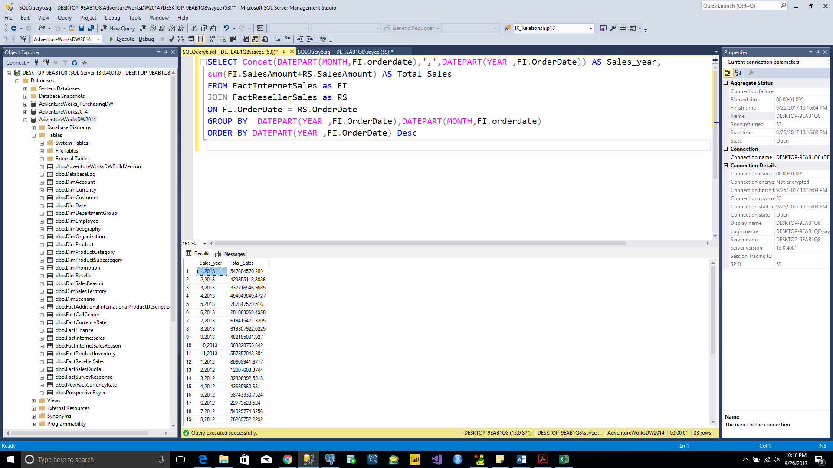

**Query 4**

* What are the reseller sales & product costs by product Hierarchy?

SELECT r.ResellerName as Reseller,

p.EnglishProductName as Product,

pca.EnglishProductCategoryName as Category,

sb.EnglishProductSubcategoryName as SubCategory,

sum(fr.SalesAmount) as Reseller_Sales,

p.StandardCost as Product_price

FROM dbo.DimReseller AS R

Join dbo.FactResellerSales AS Fr ON R.ResellerKey=Fr.ResellerKey

JOIN dbo.DimProduct AS p ON p.ProductKey=Fr.ProductKey

JOIN dbo.DimProductSubcategory AS sb ON p.ProductSubcategoryKey = sb.ProductSubcategoryKey

JOIN dbo.DimProductCategory AS pca ON sb.ProductCategoryKey = pca.ProductCategoryKey

Group by r.ResellerName, p.EnglishProductName,p.StandardCost, pca.EnglishProductCategoryName, sb.EnglishProductSubcategoryName

ORDER BY Reseller_Sales DEsc

TOTAL ROWS:-23747 rows

TABLE USED:- dbo.DimProductSubcategory, DimProduct, dbo.DimProductCategory, dbo.DimReseller

dbo.FactResellerSales

|  |  |
| --- | --- |
| INPUT COLUMNS | OUTPUT COLUMNS |
| r.ResellerName | r.ResellerName as Reseller |
| pca.EnglishProductCategoryName | p.EnglishProductName as Product |
| sb.EnglishProductSubcategoryName | pca.EnglishProductCategoryName as Category |
| p.EnglishProductName | sb.EnglishProductSubcategoryName as SubCategory |
| p.StandardCost | sum(fr.SalesAmount) as Reseller_Sales |
| fr.SalesAmount | p.StandardCost as Product_price |
| R.ResellerKey |  |
| ProductSubcategoryKey |  |
| sb.ProductCategoryKey |  |

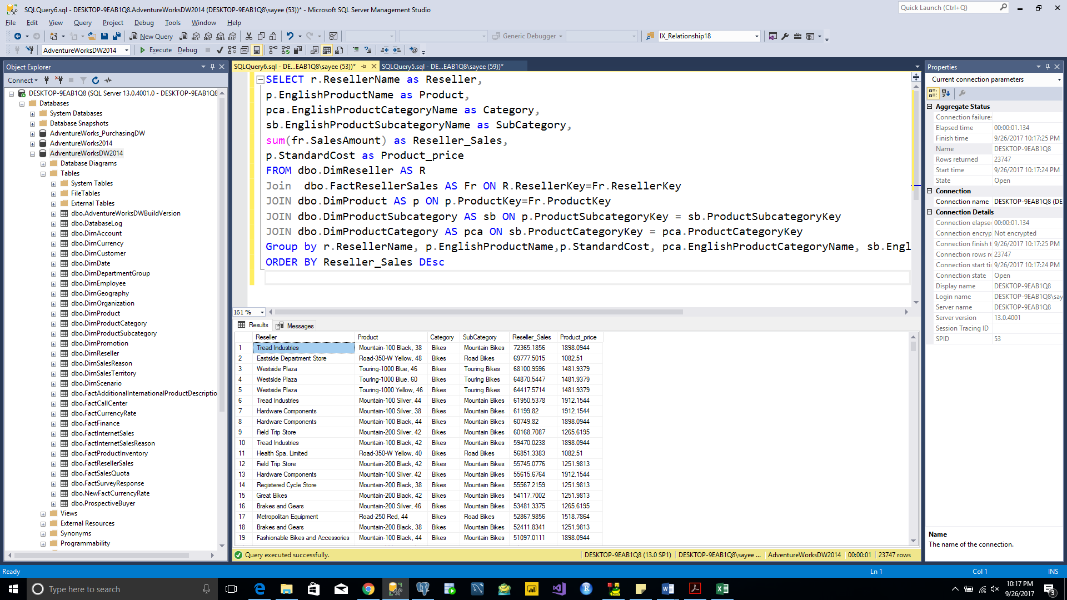

**Query 5**

* What are the internet sales & product costs by geo hierarchy?

SELECT p.EnglishProductName as Product,

pca.EnglishProductCategoryName as Category,

sb.EnglishProductSubcategoryName as SubCategory,

sum(FIS.SalesAmount) as Internet_Sales,

sum(FIS.TotalProductCost) as Product_Cost,

geo.City as City, geo.StateProvinceName as State,

geo.EnglishCountryRegionName as Country

FROM dbo.FactInternetSales AS FIS

JOIN dbo.DimProduct AS p ON P.ProductKey=FIS.ProductKey

JOIN dbo.DimProductSubcategory AS sb ON p.ProductSubcategoryKey = sb.ProductSubcategoryKey

JOIN dbo.DimProductCategory AS pca ON p.ProductSubcategoryKey = sb.ProductSubcategoryKey

JOIN dbo.DimCustomer AS CU ON FIS.CustomerKey=cu.CustomerKey

JOIN dbo.DimGeography As geo ON Cu.GeographyKey=geo.GeographyKey

GROUP BY p.EnglishProductName, pca.EnglishProductCategoryName,sb.EnglishProductSubcategoryName,

geo.City, geo.StateProvinceName,geo.EnglishCountryRegionName

ORDER BY Internet_Sales Desc

TOTAL ROWS:-23747 rows

TABLE USED:- dbo.DimProductSubcategory , DimProduct, dbo.DimProductCategory, dbo.DimReseller

dbo.FactInternetSales , dbo.DimCustomer, dbo.DimGeography

|  |  |
| --- | --- |
| INPUT COLUMNS | OUTPUT COLUMNS |
| p.EnglishProductName | p.EnglishProductName as Product, |
| pca.EnglishProductCategoryName | pca.EnglishProductCategoryName as Category, |
| sb.EnglishProductSubcategoryName | sb.EnglishProductSubcategoryName as SubCategory, |
| FIS.SalesAmount | sum(FIS.SalesAmount) as Internet_Sales, |
| FIS.TotalProductCost | sum(FIS.TotalProductCost) as Product_Cost, |
| geo.City | geo.City as City, |
| geo.StateProvinceName | geo.StateProvinceName as State |
| geo.EnglishCountryRegionName | geo.EnglishCountryRegionName as Country |

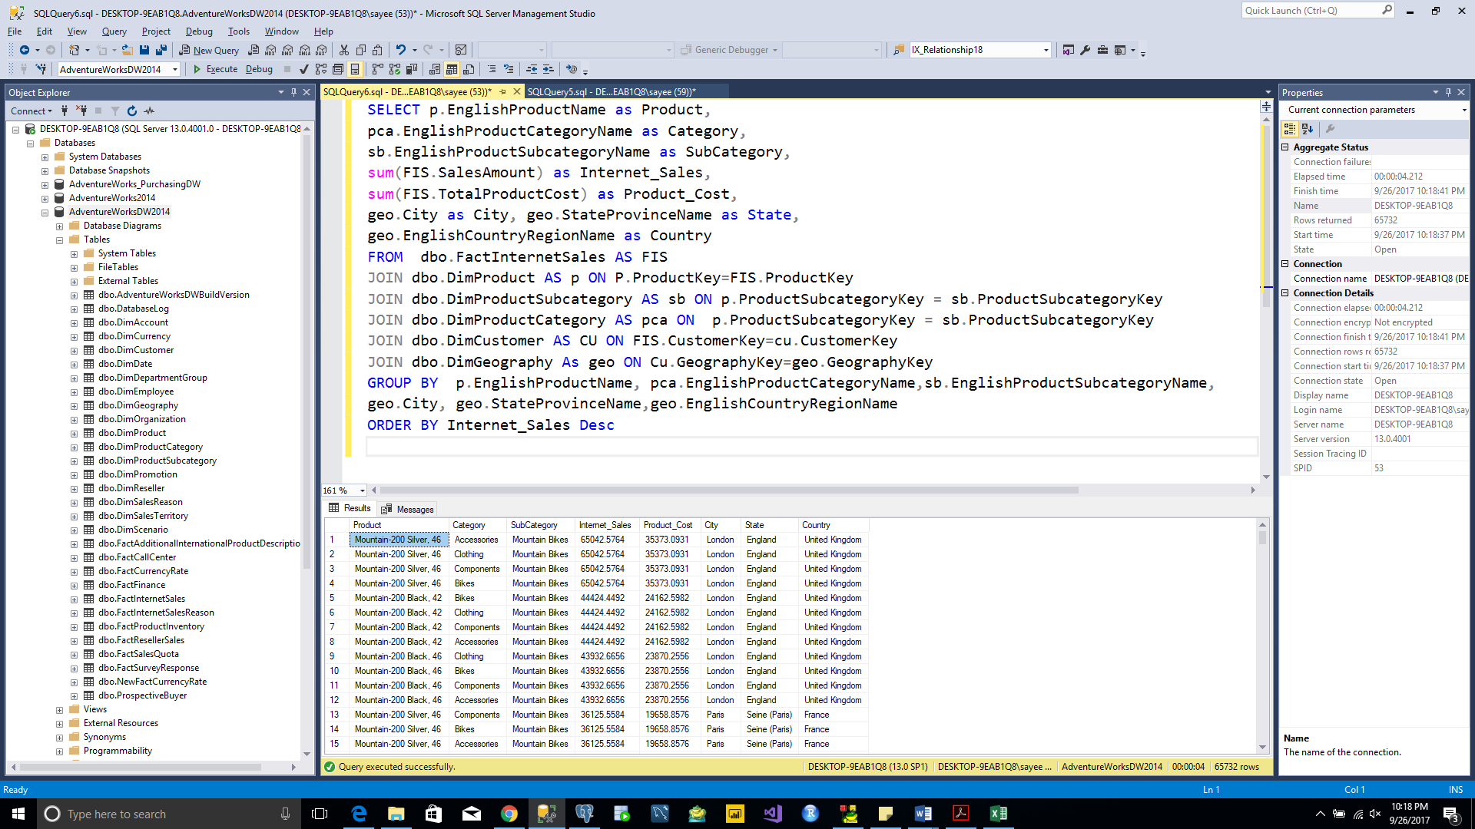

**Query 6**

* What are the ranked sales by product subcategory (largest to smallest)?

select sb.EnglishProductSubcategoryName,

sum(FR.UnitPrice*FR.OrderQuantity) as TotalSales,

rank() over (order by sum(FR.UnitPrice*FR.OrderQuantity) desc) as Rank

from FactResellerSales as FR

join DimProduct as pro on FR.ProductKey = pro.ProductKey

join DimProductSubcategory as sb

on pro.ProductSubcategoryKey = sb.ProductSubcategoryKey

group by sb.EnglishProductSubcategoryName

TOTAL ROWS:-33 rows

TABLE USED:- FactResellerSales,DimProduct,DimProductSubcategory

|  |  |
| --- | --- |
| INPUT COLUMNS | OUTPUT COLUMNS |
| FR.UnitPrice | sb.EnglishProductSubcategoryName |
| FR.ProductKey | sum(FR.UnitPrice*FR.OrderQuantity) as TotalSales, |
| sb.EnglishProductSubcategoryName | rank() over (order by sum(FR.UnitPrice*FR.OrderQuantity) desc) as Rank |
| pro.ProductKey |  |
| pro.ProductSubcategoryKey |  |
| sb.ProductSubcategoryKey |  |

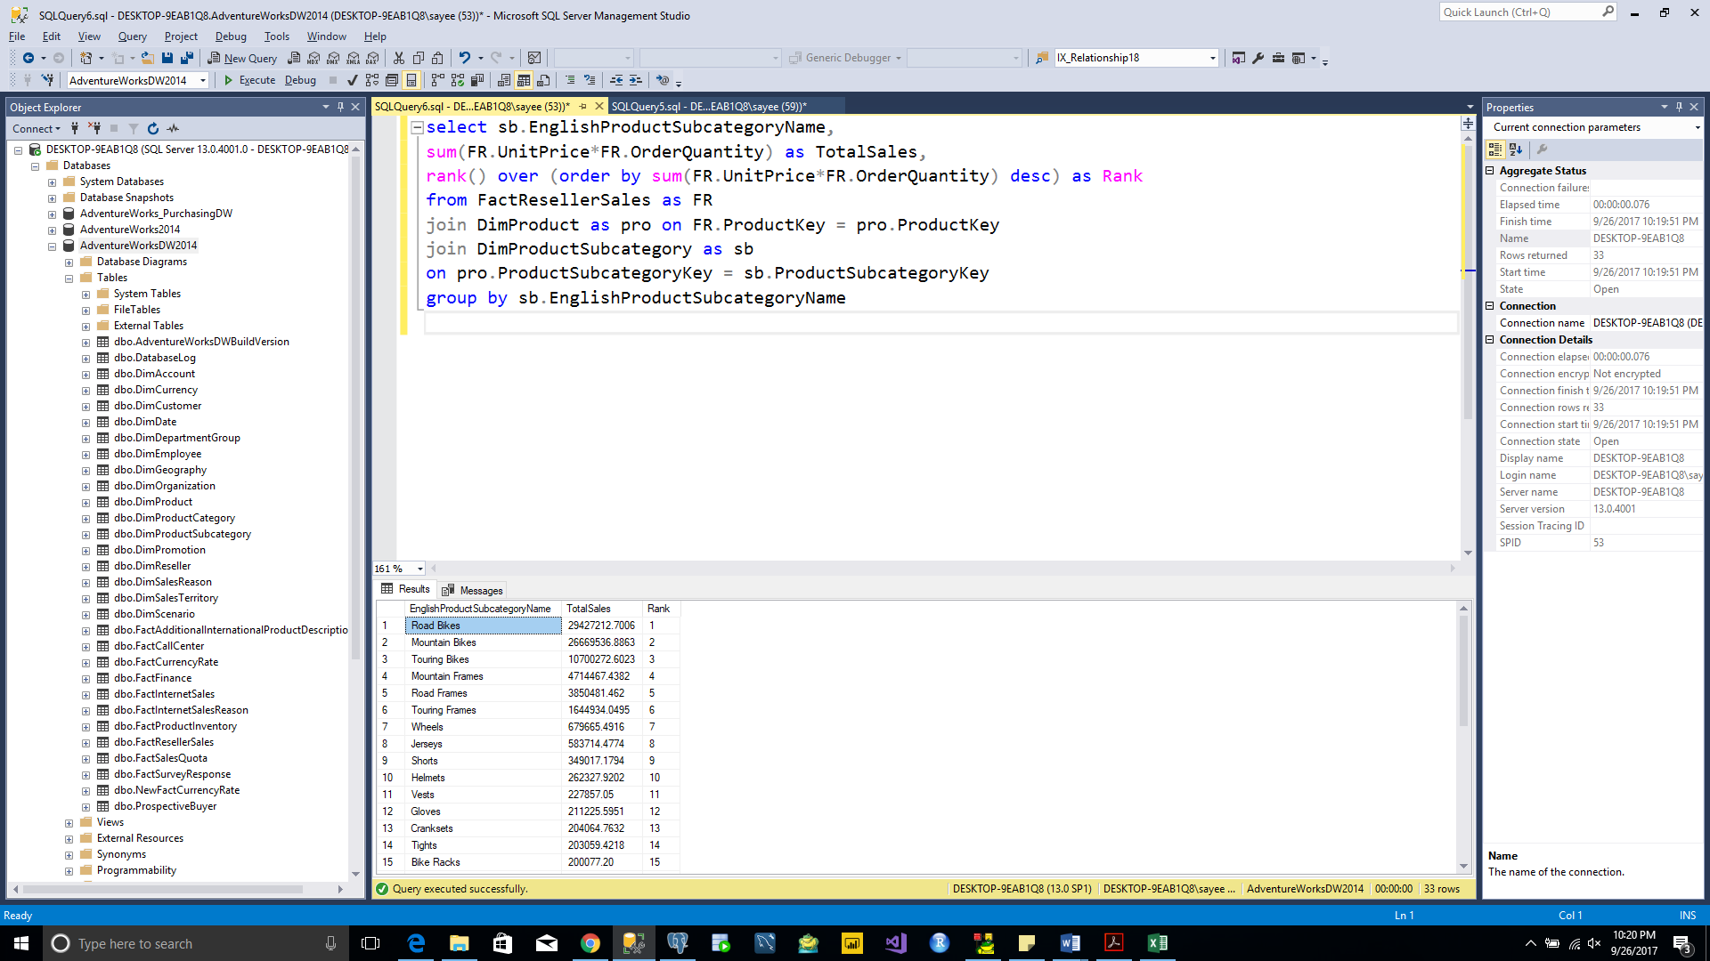

**Query 7**

* What are the top ten resellers by profit?

SELECT TOP(10) RS.ResellerName,

sum((FR.UnitPrice*FR.orderQuantity)-FR.ProductStandardCost) as profit

FROM FactResellerSales as FR

JOIN DimReseller as RS

ON RS.ResellerKey=FR.ResellerKey

GROUP BY RS.ResellerName

TOTAL ROWS:-10 rows

TABLE USED:- FactResellerSales, DimReseller

|  |  |
| --- | --- |
| INPUT COLUMNS | OUTPUT COLUMNS |
| RS.ResellerName | RS.ResellerName |
| FR.UnitPrice | sum((FR.UnitPrice*FR.orderQuantity)-FR.ProductStandardCost) as profit |
| FR.orderQuantity |  |
| FR.ProductStandardCost |  |
| RS.ResellerKey |  |
| FR.ResellerKey |  |

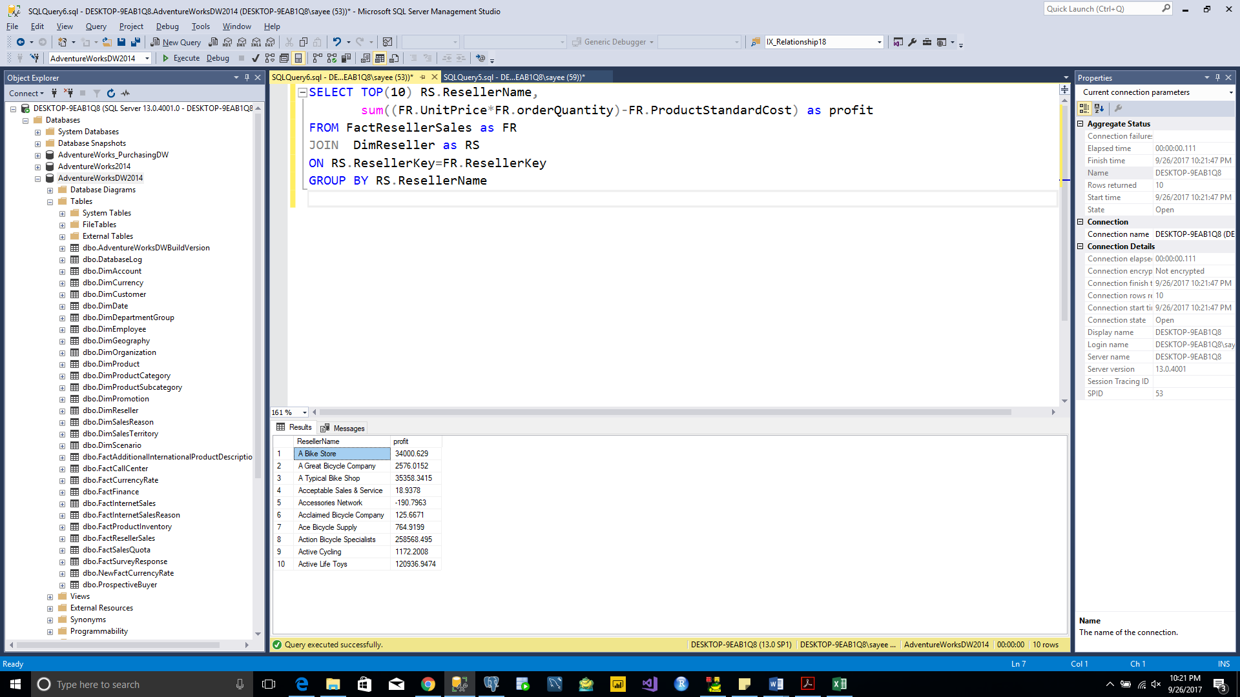

**Query 8**

* What are the top ten (internet) customers by profit?

SELECT TOP(10) FI.CustomerKey,

CONCAT(CU.LastName,',',CU.FirstName) AS Customer ,

SUM((FI.SalesAmount + FI.TaxAmt + FI.Freight) - (FI.TotalProductCost*FI.OrderQuantity)) AS Profit

FROM FactInternetSales AS FI

JOIN DimCustomer as CU

ON FI.CustomerKey = CU.CustomerKey

GROUP BY FI.CustomerKey,CU.LastName,CU.FirstName

TOTAL ROWS:-10 rows

TABLE USED:- FactInternetSales, DimCustomer

|  |  |
| --- | --- |
| INPUT COLUMNS | OUTPUT COLUMNS |
| FI.CustomerKey | CONCAT(CU.LastName,',',CU.FirstName) AS Customer |
| CU.LastName | FI.CustomerKey |
| CU.FirstName | SUM((FI.SalesAmount + FI.TaxAmt + FI.Freight) - (FI.TotalProductCost*FI.OrderQuantity)) AS Profit |
| FI.TotalProductCost |  |
| FI.SalesAmount |  |
| FI.TaxAmt |  |
| FI.Freight |  |
| FI.TotalProductCost |  |
| FI.OrderQuantity |  |

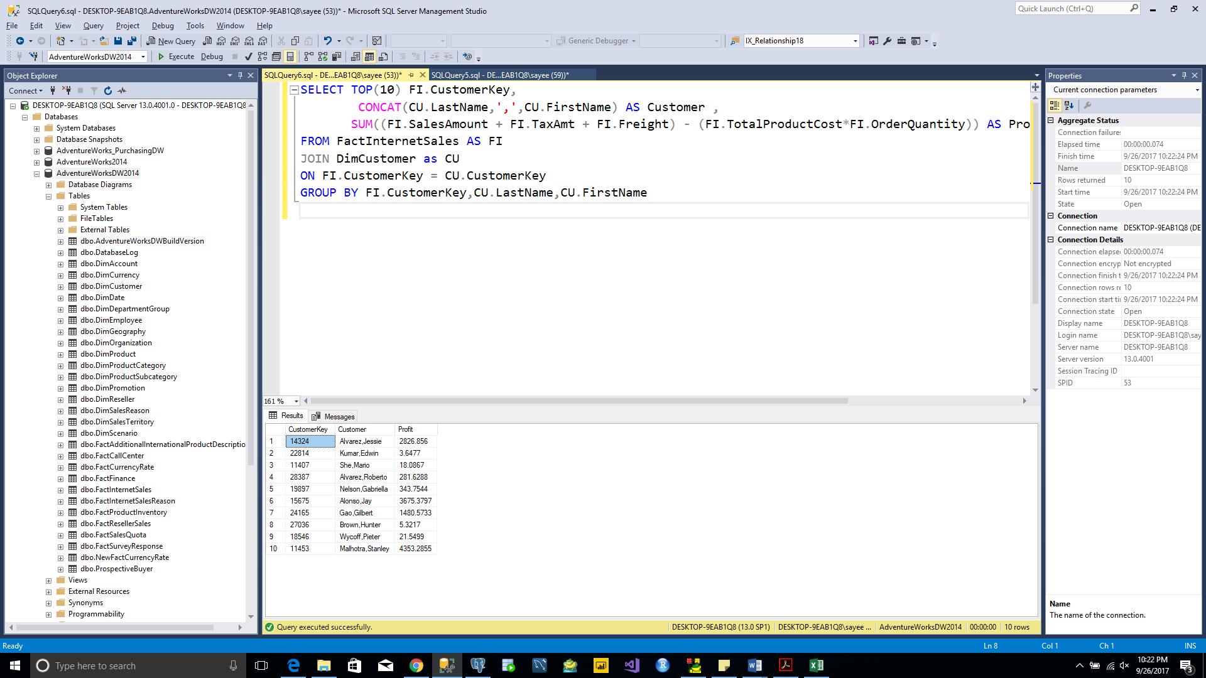

**Query 9**

* What are the total sales by country ranked (largest to smallest)?

SELECT ST.SalesTerritoryCountry AS Country,

SUM(FI.SalesAmount + RS.SalesAmount) AS Total_Sales,

rank() over (order by SUM(FI.SalesAmount + RS.SalesAmount) desc) as Rank

FROM FactInternetSales as FI

JOIN DimSalesTerritory as ST

ON FI.SalesTerritoryKey = ST.SalesTerritoryKey

JOIN FactResellerSales as RS

ON RS.SalesTerritoryKey = ST.SalesTerritoryKey

GROUP BY ST.SalesTerritoryCountry

TOTAL ROWS:-6 rows

TABLE USED:- FactInternetSales, DimSalesTerritory, FactResellerSales

|  |  |
| --- | --- |
| INPUT COLUMNS | OUTPUT COLUMNS |
| FI.SalesAmount | rank() over (order by SUM(FI.SalesAmount + RS.SalesAmount) desc) as Rank |
| RS.SalesAmount | ST.SalesTerritoryCountry |
| ST.SalesTerritoryCountry | SUM(FI.SalesAmount + RS.SalesAmount) AS Total_Sales |
| FI.SalesTerritoryKey |  |
| ST.SalesTerritoryKey |  |
| RS.SalesTerritoryKey |  |

